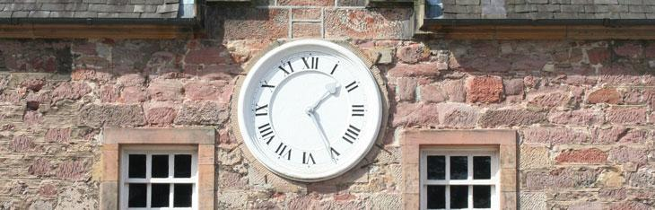


Booking Form – Christmas Fayre

Company: ………………………………………….………………………………….....................

Nature of Business: :………………………………………………………………………………………….…………………………………………………………………………………………..…………………………………………………………………………………………..
ElectricalRequirements:……………………………………………………………....
Contact Name:…………………………………………………………………………
Contact Telephone Number:………………………………………………………….
Website:…………………………………………………………………………….......
Email:…………………………………………………………………………………..

Date: weekend of 8th /9th and 15th /16th December 2012

Time: Exhibiting 10.30 am -3.30 pm
Access available on site for set up from 9.00am or by arrangement
Exhibitors are encouraged not to leave until after 3.30pm

Charge: £50 per day, £95 per weekend or £180 for both weekends – Cash acceptable or cheque made payable to “BRE Ltd”. Cancellations made less than 1 week before the event will still need to pay.

Location
Travel directions for Dalkeith can be found on our website http://www.dalkeithcountryestate.com/How+To+Find+Us

The craft area will be based in the Stableyard area.

Stalls are based inside the stable areas and are 6ft x 4ft.

Please note no vehicles are allowed in the stable yard area however there is an area to drop things off at the entrance to the stable yard but vehicles must be moved from here and parked in the public car park.

Your Contact
Iain Herbert or Jo Kirkhope – 0131 561 5015
Please Note:
By law, all enclosed public spaces, this includes marquees, must be kept smoke free. Council Smoking Inspectors, who are not employed by Dalkeith Country Estate, may attend and will issue a fine if someone is smoking in an enclosed area. Dalkeith Country Estate will not be liable for this fine.

Exhibitors hire space at their own risk, therefore all exhibitors must complete a risk assessment for their stand to identify any potential risks and if applicable, take steps to reduce the likelihood of injury occurring. Completed risk assessments must accompany all applications.

We reserve the right to turn down an applicant if we believe they are not in keeping with the nature of our business or the event.

All stands must be covered by public liability insurance. All liability on trade/craft stands lies with the particular exhibitor who is responsible for obtaining his/her own public liability insurance.

Stand holders are responsible for insurance against personal effects, theft & third party damage to their stands, exhibits, property and personal effects. Trade stand holders are also responsible for any damage caused by them to any property belong to Dalkeith Country Estate.

I have read and agreed to the above

Signature: ……………………………………………………………………………

